EXP:4
Non-preemptive SJF Scheduling
Note: Uses burst times 6, 2, 8, 3.
CODE:
#include <stdio.h>
int main(void) {
int bt[] = {
6, 2, 8, 3
}, p[] = {
1, 2, 3, 4
}, n = 4, i, j, t, wt[4], tat[4];
for (i = 0; i < n - 1; i++)
for (j = i + 1; j < n; j++)if (bt[i] > bt[j]) {
t = bt[i];
bt[i] = bt[j];
bt[j] = t;
t = p[i];
p[i] = p[j];
p[j] = t;
}
wt[0] = 0;
for (i = 1; i < n; i++)
wt[i] = wt[i - 1] + bt[i - 1];
puts("Order Burst Waiting Turnaround");
for (i = 0; i < n; i++) {
tat[i] = wt[i] + bt[i];
printf("P%d %d %d %d\n", p[i], bt[i], wt[i], tat[i]);
}
return 0;
}
OUTPUT:
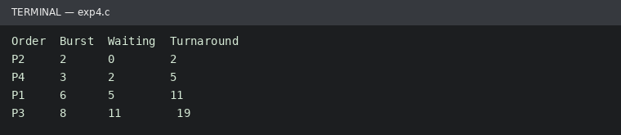
Run status: Ran successfully

